Has anyone heard of "Regular Expression / Text Pattern Matching" before? (Please share your experiences. I love it.) “Regular Expression / Text Pattern Matching” is a critical feature in the Linux OS, and is supported in all modern programming languages. In its essence, it is a rendition of Finite State Machine.

One can get a jump start to it by learning it from this link:

<http://www.regexr.com/>

Example of the default session interface:

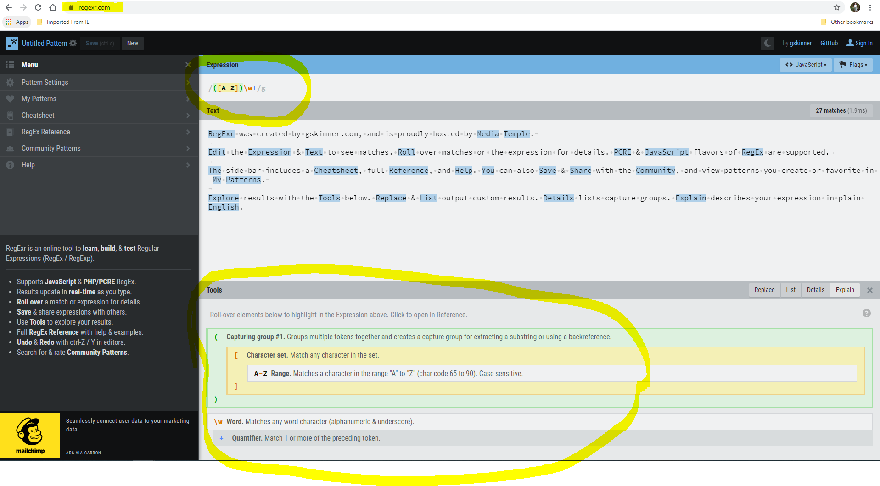

Lab Instructions:

1. What is your overall understanding of what the Website provides/does? (Please elaborate and capture your inputs below below)

This website is used to learn, test and build regular expressions. Simply, it is a tool for filtering strings.

1. What does the expression “/([A-Z])\w+/g “ do?

Filter out words that begins with uppercase letters.

1. Per Website, let’s be sure its “Text” entry are as follows:

-----------------------------------------------------------

RegExr was created by gskinner.com, and is proudly hosted by Media Temple.

Edit the Expression & Text to see matches. Roll over matches or the expression for details. PCRE & JavaScript flavors of RegEx are supported.

The side bar includes a Cheatsheet, full Reference, and Help. You can also Save & Share with the Community, and view patterns you create or favorite in My Patterns.

Explore results with the Tools below. Replace & List output custom results. Details lists capture groups. Explain describes your expression in plain English.

------------------------------------------------------------

(Or as seen in RegExr.com default interface shown in the last image.)

Question: What does the expression “/&.*&/g “ do?

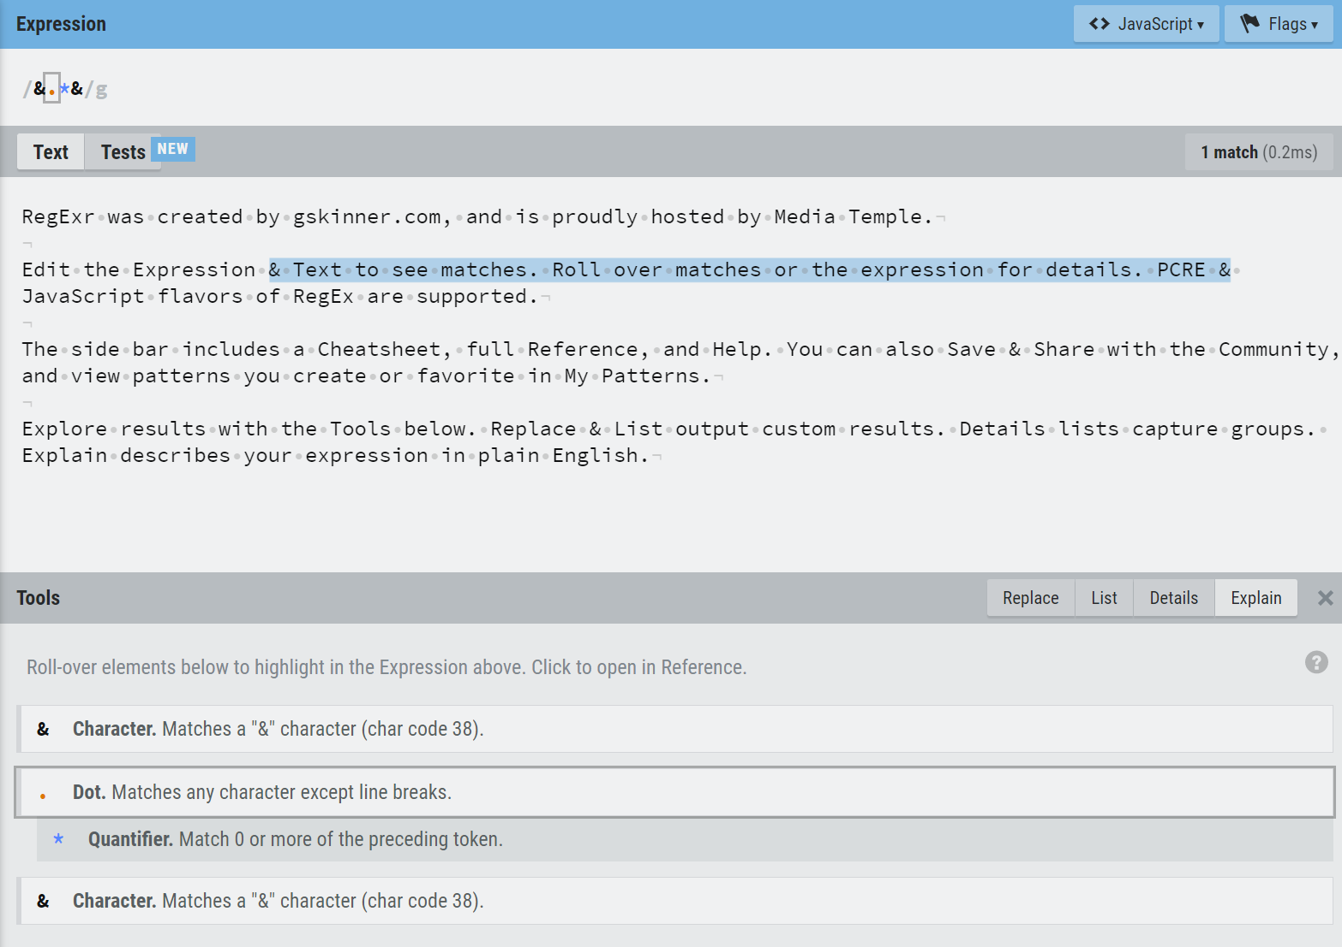

Filter out the sentence between the first & and the next & encountered.

1. Now suppose “&” is as a **tag**, and *the text strings between “&” can vary/dynamic*. Come up with the expression that matches the text string as shown below:

&.*[\s\S]*&

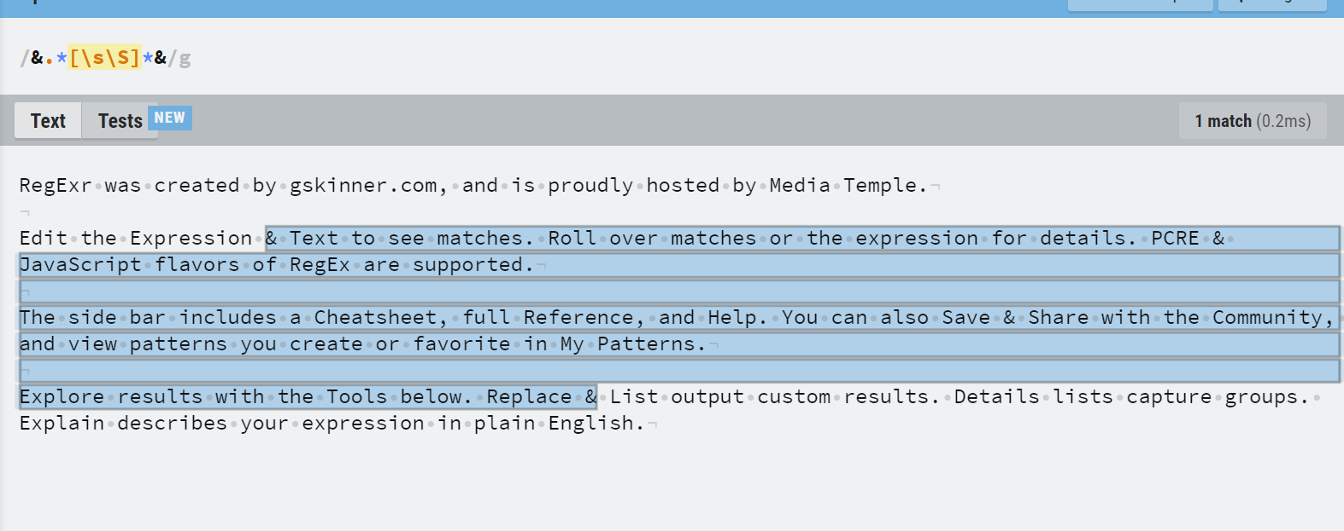

Bonus: Come up with the expression that matches the text string as highlighted below (*Remember, you cannot use the dynamic/variable text string as your search pattern*):

& Share.*[\S]|Explore.*&

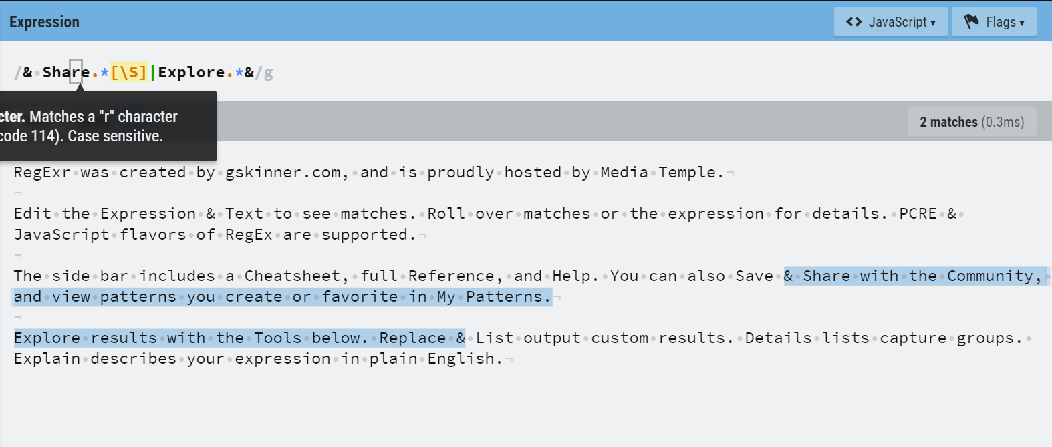

1. Copy and paste the content area of <https://en.wikipedia.org/wiki/URL> onto the text area of RegExr.com

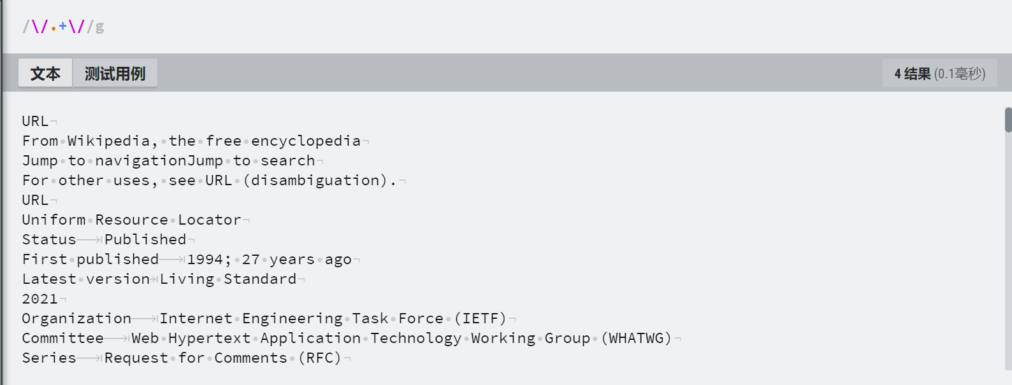

Please explore additional features by clicking on the “Cheatsheet” tab. Explain what does this search expression does: “/\/.+\//g”?

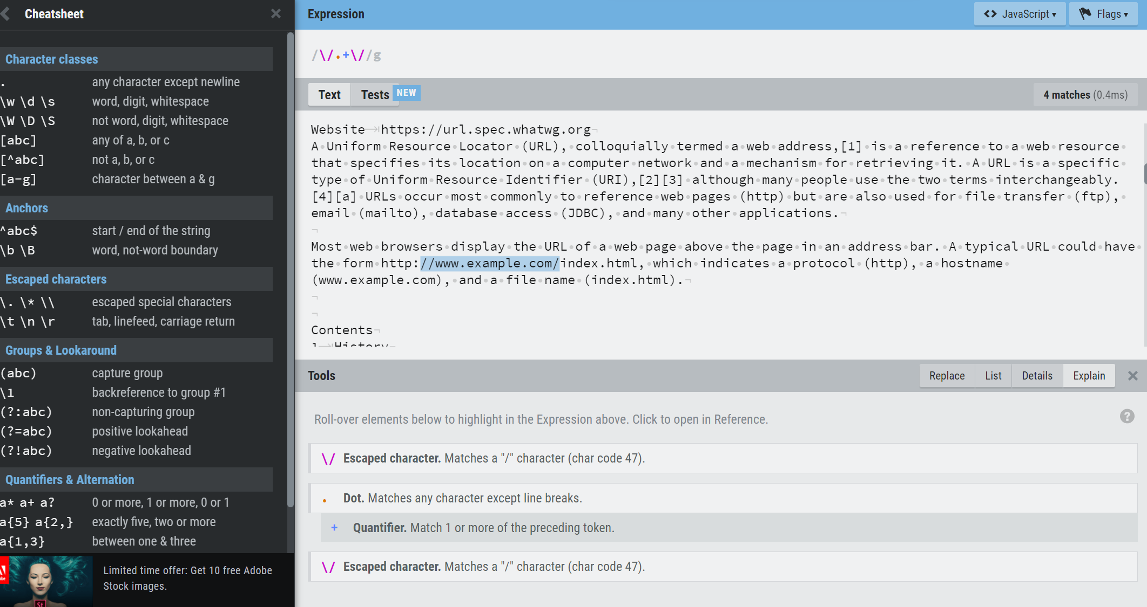

Match sentence from / to /.

1. Please refine the search in d) by matching text/pattern located between any “/…./” (e.g. /foo.co.uk/)

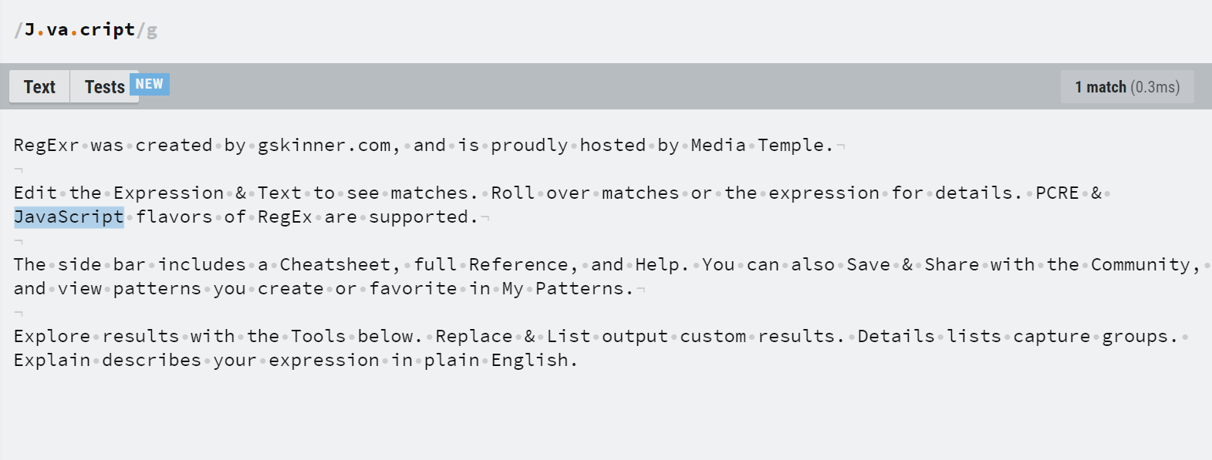

1. Do you think this text search/pattern matching feature is useful in data processing/programing? Per [www.regexr.com](http://www.regexr.com), how would you extract the matches (dynamic/variable text string) we found from the last step? (Hint: “Back Reference” per Cheat Sheet seen in www.regexr.com).

Yes, it is very useful.

Select the colored statement and copy it.

Lab assignment Deliverables:

* Show that you have visited and tested at www.regexr.com.
* Per Lab instruction, submit your practice session results by copy/paste or attached screenshots onto this document.

**Submission:**

Please submit to online. If that fails, email your results to: [bangpanliang@gmail.com](mailto:jcc4018@qq.com).

The subject of the email should be:

[Your StudentID, Assignment Name]